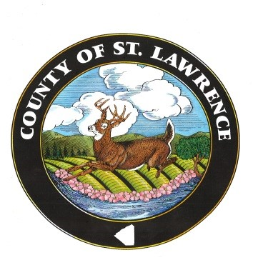
ST. LAWRENCE COUNTY BOARD OF LEGISLATORS
48 COURT STREET
CANTON, NY 13617-1194
(315) 379-2276
FAX: (315) 379-2463

FOR IMMEDIATE RELEASE

To: All Interested Parties

From: Kelly Bigwarfe, Deputy Clerk

Date: May 11, 2023

Re: Parking at the County Court House

Due to two scheduled criminal jury trials, and a high volume of expected jurors, parking at the St. Lawrence County Court House will be at a minimum on Monday, May 15th and Tuesday, May 16th, 2023, with the possibility of Wednesday, May 17th, as well. Please practice parking etiquette, be patient, and allow yourself extra time on those days.

