FOR IMMEDIATE RELEASE:
6/19/23

St. Lawrence County Office for the Aging Farmers Market Coupon - July Distribution Schedule

The Office for the Aging will be distributing Farmers Market Coupons starting July 3rd. Please see the schedule below for a list of when coupons will be at a location near you. For more information, please call 315-386-4730. Schedule subject to change based on coupon availability.

*If you would like to request public transportation a Distribution Site, please call Public Transportation at 315-386-2600 for more information.

Rules and Procedures For All Distribution Sites:
- Only one coupon booklet, per eligible senior in each household; while quantities last.
- The eligible senior must sign up in person. An eligible Health Care Proxy or Power of Attorney with proper paperwork; can sign for the coupons.

Farmers Market Coupon Eligibility Requirements: 1. Must be age 60 or above and
2. Monthly Income at/or Below 185% of Federal Poverty Level: $1,986/one person-household; $2,686/two-person household; $3,386/three-person household; $4,085/four-person household; $4,758/five-person household

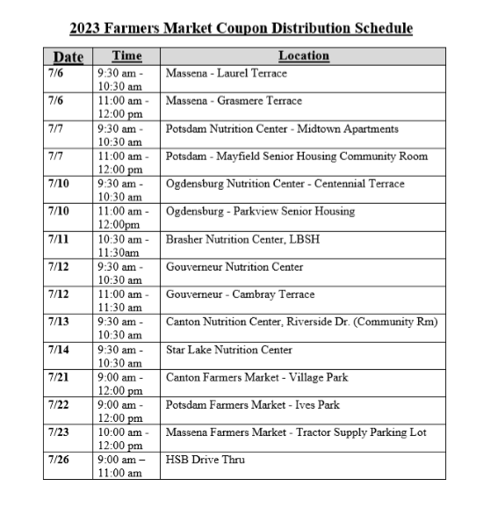
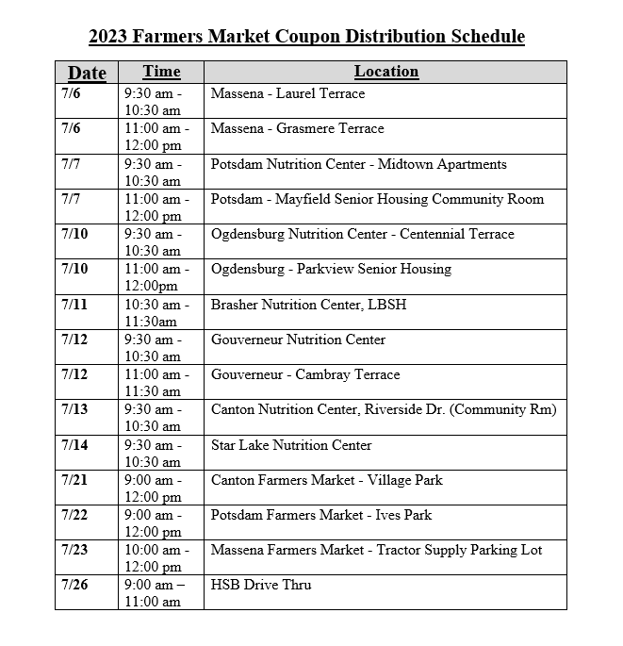
About St. Lawrence County Office for the Aging:

The Office for the Aging provides service and advocacy for county residents 60 years and older. Programs and services includes: Nutrition Centers and Home Delivered Meals; Home Care Services; Family Caregiver Support; Senior Community Service Employment Program; Medical Transportation; Legal Services; Health Insurance Information Counseling and Assistance. The Office’s mission is to develop a service system specifically designed to best meet the social and human needs of the elderly.

Contact:
Andrea Montgomery
Department Head
St. Lawrence County Office for the Aging
(315) 386-4730
amontgomery@stlawco.org

