FOR IMMEDIATE RELEASE:
6/23/25

St. Lawrence County Office for the Aging Farmers Market Coupon - July Distribution Schedule

The Office for the Aging will be at all of the distribution locations below in July with Farmers Market Coupons. Please note, our in-office distribution normally starts July 1st; however it may be delayed as the coupons haven’t been shipped from the State as of the date of this press release. We will post signs up on the outside door of the building if we do not have the coupons for in office distribute starting July 1st.

Eligible clients will be able to pick them up in person at the office, Monday - Friday between the hours of 8 am - 4 pm. Please note that the office will be closed on July 4th. Please see the distribution schedule below for when we will be in your area with the coupons. For more information, please call 315-386-4730. Schedule subject to change based on coupon availability. *If you need a ride to a Distribution Site, please call Public Transportation at 315-386-2600 and ask about the First Mile, Last Mile Program!

Rules and Procedures For All Locations:
- Only one coupon booklet, per eligible senior in each household; while quantities last.

- The eligible senior must sign up in person. An eligible Health Care Proxy or Power of Attorney with proper paperwork and a proxy form signed in advance (available at the Office for the Aging); can sign for the coupons.

Farmers Market Coupon Eligibility Requirements:
- Must be age 60 or above AND

2. Monthly Income at/or Below 185% of Federal Poverty Level: $2,413/month (for a one-person household); Or $3,261/month (for a two-person household); Or $4,109/month (for a three-person household)
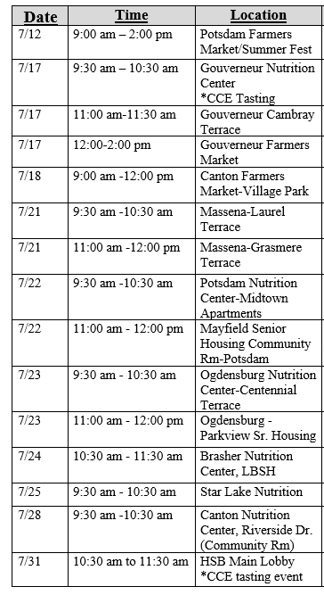

# In Photo: Distribution Schedule

About St. Lawrence County Office for the Aging:

The Office for the Aging provides service and advocacy for county residents 60 years and older. Programs and services includes: NY Connects, Nutrition Centers and Home Delivered Meals; Home Care Services; Family Caregiver Support; Medical Transportation; Legal Services; Health Insurance Information Counseling and Assistance. The Office’s mission is to develop a service system specifically designed to best meet the social and human needs of the elderly.

Contact:
Andrea Montgomery
Director
St. Lawrence County Office for the Aging
(315) 386-4730
amontgomery@stlawco.gov

