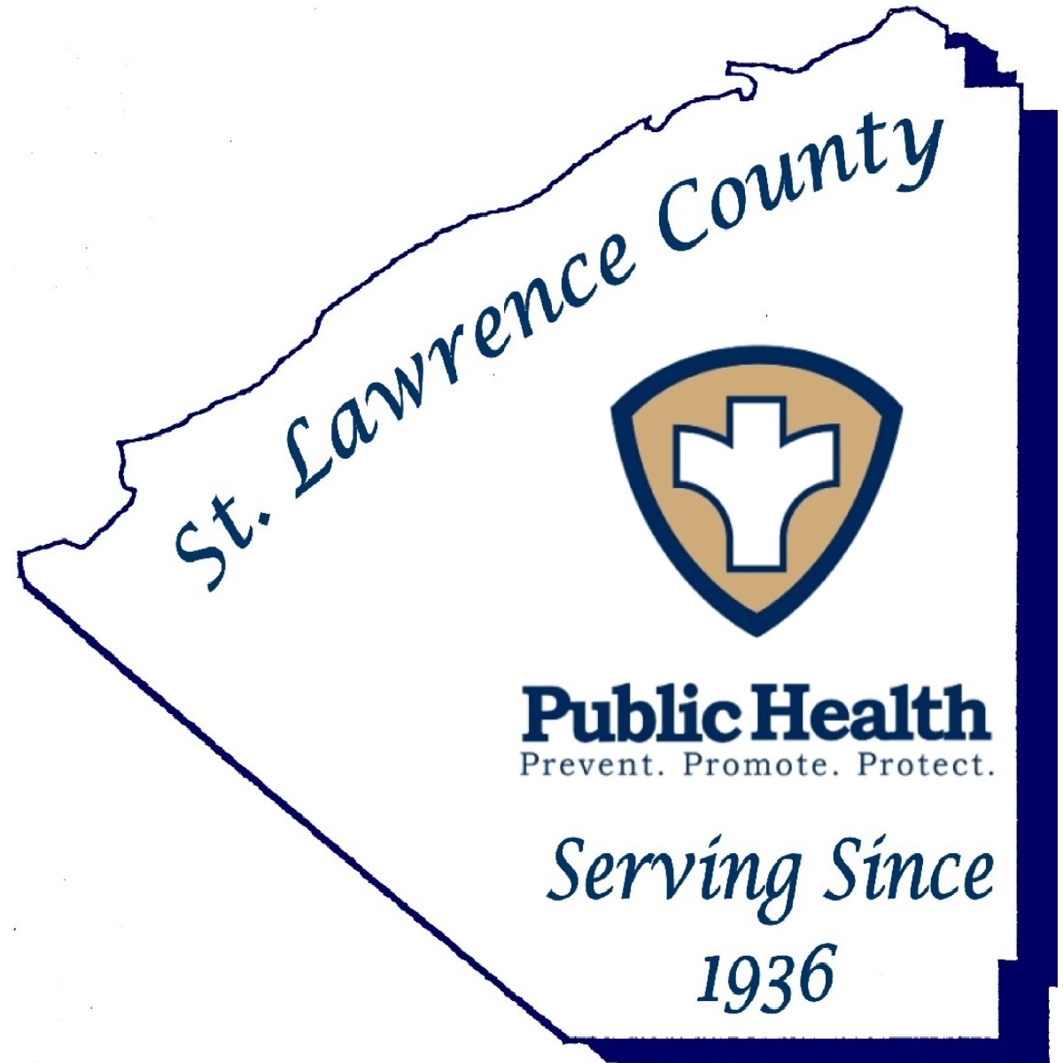

St. Lawrence County Public Health Department

Jolene Munger, MPH, MA ■ Interim Public Health Director

80 State Highway 310, Suite 2 ■ Canton, New York 13617-1476
Phone: (315) 386-2325 ■ Fax: (315) 386-2203

Press Release
Date: 8/17/2021
FOR IMMEDIATE RELEASE
Contact: Jolene Munger
Phone: 315-386-2325
Email: jmunger@stlawco.org

ST. LAWRENCE COUNTY PUBLIC HEALTH RECOMMENDS
ALL PERSONS WEAR A MASK WHILE INDOORS IN ACCORDANCE WITH RECENT CDC GUIDANCE

Canton, NY --- As our communities continue to experience a significant rise in positive COVID-19 cases, St. Lawrence County has moved quickly from a designation of moderate to high transmission in less than a week. The Public Health Department is recommending the continuation of mitigation strategies that provide for a safe reopening of schools, maintaining open businesses, and allowing for events to occur.

These mitigation strategies include the five pillars of prevention recommended by the Public Health Department which are comprised of; social distancing, mask wearing, staying home if you are sick, hand washing, and now vaccination.

“Due to the increased number of cases and the confirmed presence of the Delta variant in New York State, Public Health strongly urges and recommends that ALL PERSONS wear a mask indoors in public spaces, in accordance with recent CDC guidance,” St. Lawrence County Interim Director of Public Health, Jolene Munger said on Tuesday.

As of this week, the positive COVID-19 cases have risen to a daily average of 31 new cases per day, up from 2 new cases per day just four weeks ago. This increase equates to a 141% increase of cases in the last seven days.

At this time, approximately 50% of St. Lawrence County is fully vaccinated.
County residents can find information on upcoming vaccination clinics and register for an appointment to receive a Pfizer vaccine at the St. Lawrence County Public Health website at https://stlawco.org/Departments/PublicHealth or by calling 315-229-3452.

###

