FOR IMMEDIATE RELEASE:
7/19/22

St. Lawrence County Office for the Aging Farmers Market Coupon Distribution Schedule

The St. Lawrence County Office for the Aging has received their allotment of Farmers Market Coupons for income eligible older adults, 60 and up. Please see the distribution schedule below for when we will be in your community. Individuals can sign up for coupons at our office located in the Human Services Building, 80 State Highway 310, 1st Floor, Canton.

To be eligible to receive Farmers Market Coupons, you must be 60 years of age and older AND meet the following income requirements: Monthly Income is at or below: $2,096/month (for a one-person household); Or $2,823/month (for a two-person household); Or $3,551/month (for a three-person household).

Applicants must apply in person. A caregiver can apply for the client, but must have a copy of the Power of Attorney paperwork with them. There are a limited supply of coupons; therefore distribution dates could be changed if coupons are gone. For more information, please call (315) 386-4730.
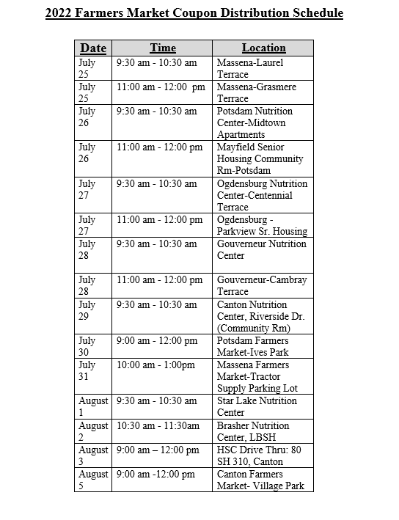

# # #

About St. Lawrence County Office for the Aging:

The Office for the Aging provides service and advocacy for county residents 60 years and older. Programs and services includes: Nutrition Centers and Home Delivered Meals; Home Care Services; Family Caregiver Support; Senior Community Service Employment Program; Medical Transportation; Legal Services; Health Insurance Information Counseling and Assistance. The Office’s mission is to develop a service system specifically designed to best meet the social and human needs of the elderly.

Contact:
Andrea Montgomery
Department Head
St. Lawrence County Office for the Aging
(315) 386-4730
amontgomery@stlawco.org

