ST. LAWRENCE COUNTY
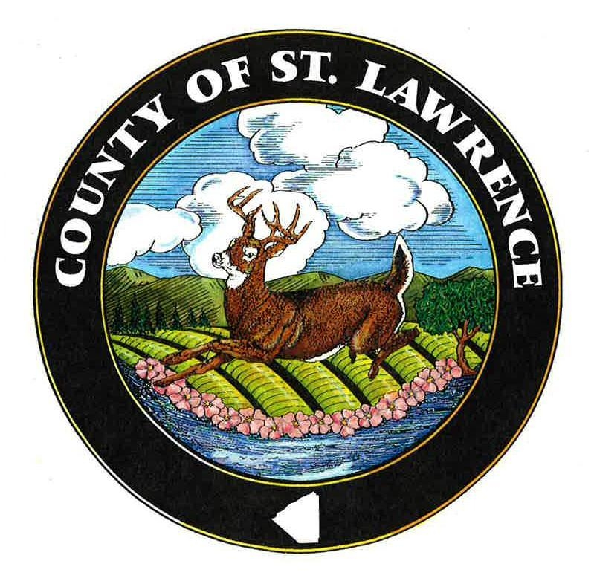

REAL PROPERTY TAX SERVICES
www.stlawco.org/departments/realproperty/
______________________________________________________________________________

Frequently Asked Questions

- Who can access real property information?
Starting in early 2023 there will be two options to access real property information. There will be a free Public Access version and a subscription Advanced Access version ($350/yr.). A ten-day free trial (one time use only) is also available, to check out the subscription version prior to purchasing it.

- Is there anything new?
Yes! You now have the ability to print a tax bill, with either the free or subscription version.

- What does the subscription version offer that the free version does not?
- daily updated ownership and sales information - the free version updates this information after the Final Assessment Roll on July 1.
- comparable property search - you can select property fields, then run a report
- the ability to view and print tax Information and run a report
- the ability to view and print tax maps

- How do I get started?
- For the free Public Access version - go to: https://stlawrencepublic.sdgnys.com/index.aspx?cty=40Public
- For the subscription Advanced Access version – please fill out the Image Mate Online License Application then email to Joycee at jchakranarayan@stlawco.org or
fax to 315-229-3222. You can also mail it to our office at:
St. Lawrence County Real Property Office, 48 Court St., Canton, NY 13617

- Once I pay the subscription fee how do I access the information?
Once we receive your signed License Application and payment, you will usually have access within 24 hours. A signed License Agreement and the login instructions will be emailed to you on how to access the site.

- What is available?
Assessment roll information including property information, ownership, sales, tax bill, inventory information and digital tax maps are available. Also available are mapping views through Google Maps, BING Maps and Pictometry. Information can be viewed by municipality, tax map number, owner name or address. The information is available 24 hours a day, 365 days per year.

7. How current is the information?
Assessments and digital tax maps are updated annually, inventory and improvement information is updated daily. Ownership and sales information is updated daily on the subscription version, but is only updated on May 1 and July 1 on the free version.

Tax bill information can also be looked up on: www.taxlookup.net
Tax rates, assessment rolls and tax rolls can be found at: www.stlawco.org/departments/realproperty
Any questions – please contact Joycee Chakranarayan: jchakranarayan@stlawco.org (315) 379- 2272 Ref: sharedrive/ACCOUNTCLERK-Joycee/Imagemateonline/FAQ 2023.doc

